SELECT * FROM Blinkit_Data

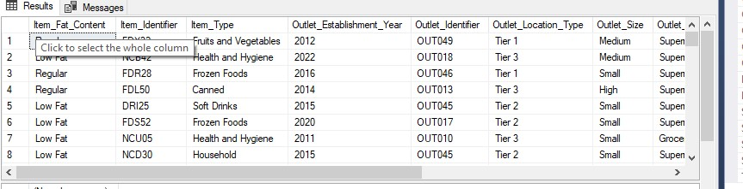

UPDATE Blinkit_Data

SET Item_Fat_Content =

CASE

WHEN Item_Fat_Content IN ('LF', 'low fat') THEN 'Low Fat'

WHEN Item_Fat_Content = 'reg' THEN 'Regular'

ELSE Item_Fat_Content

END

(8523 rows affected)

Completion time: 2025-06-20T23:23:37.3812292+05:30

SELECT CAST(SUM(Sales)/ 1000000 AS DECIMAL(10,2)) AS Total_Sales_Millions

FROM Blinkit_Data

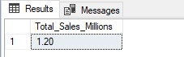

SELECT CAST(AVG(Sales) AS DECIMAL(10,2)) AS Avg_Sales

FROM Blinkit_Data



SELECT COUNT(*) AS No_of_Item

FROM Blinkit_Data



SELECT CAST(AVG(Rating) AS DECIMAL(10,2)) AS Avg_Rating

FROM Blinkit_Data



SELECT Item_Fat_Content, CAST(SUM(Sales) AS DECIMAL(10,2)) AS Total_Sales

FROM Blinkit_Data

GROUP BY Item_Fat_Content

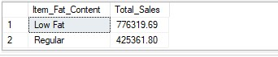

SELECT Item_Fat_Content,

CAST(SUM(Sales) AS DECIMAL(10,2)) AS Total_Sales,

CAST(AVG(Sales) AS DECIMAL(10,2)) AS Avg_Sales,

COUNT(*) AS No_of_Item,

CAST(AVG(Rating) AS DECIMAL(10,2)) AS Avg_Rating

FROM Blinkit_Data

GROUP BY Item_Fat_Content

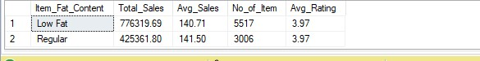

SELECT Item_Type,

CAST(SUM(Sales) AS DECIMAL(10,2)) AS Total_Sales,

CAST(AVG(Sales) AS DECIMAL(10,2)) AS Avg_Sales,

COUNT(*) AS No_of_Item,

CAST(AVG(Rating) AS DECIMAL(10,2)) AS Avg_Rating

FROM Blinkit_Data

GROUP BY Item_Type

ORDER BY Total_Sales DESC

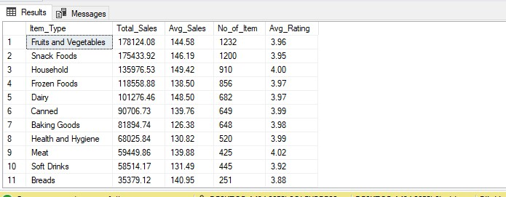

SELECT Outlet_Establishment_Year, Item_Fat_Content,

CAST(SUM(Sales) AS DECIMAL(10,2)) AS Total_Sales,

CAST(AVG(Sales) AS DECIMAL(10,2)) AS Avg_Sales,

COUNT(*) AS No_of_Item,

CAST(AVG(Rating) AS DECIMAL(10,2)) AS Avg_Rating

FROM Blinkit_Data

GROUP BY Outlet_Establishment_Year, Item_Fat_Content

ORDER BY Total_Sales DESC

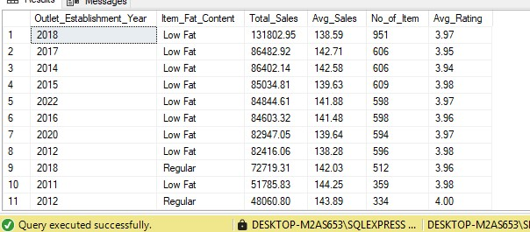

SELECT Outlet_Location_Type,

ISNULL([Low Fat], 0 ) AS Low_Fat,

ISNULL([Regular], 0 ) As Regular

FROM

(

SELECT Outlet_Location_Type, Item_Fat_Content,

CAST(SUM(Sales) AS DECIMAL(10,2)) AS Total_Sales

FROM Blinkit_Data

GROUP BY Outlet_Location_Type, Item_Fat_Content

)

AS SourceTable

PIVOT

(

SUM(Total_Sales)

FOR Item_Fat_Content IN ([Low Fat], [Regular])

)

AS PivotTable

ORDER BY Outlet_Location_Type;

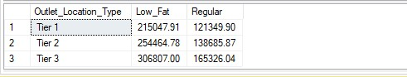

SELECT Outlet_Establishment_Year,

CAST(SUM(Sales) AS DECIMAL(10,2)) AS Total_Sales,

CAST(AVG(Sales) AS DECIMAL(10,2)) AS Avg_Sales,

COUNT(*) AS No_of_Item,

CAST(AVG(Rating) AS DECIMAL(10,2)) AS Avg_Rating

FROM Blinkit_Data

GROUP BY Outlet_Establishment_Year

ORDER BY Total_Sales DESC

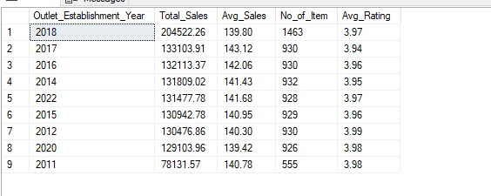

SELECT Outlet_size,

CAST(SUM(Sales) AS DECIMAL(10,2)) AS Total_Sales,

CAST((SUM(Sales) * 100 / SUM(SUM(Sales)) OVER()) AS DECIMAL(10,2)) AS Sales_Percentage

FROM Blinkit_Data

GROUP BY Outlet_Size

ORDER BY Total_Sales DESC

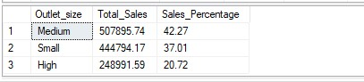

SELECT Outlet_Location_Type,

CAST(SUM(Sales) AS DECIMAL(10,2)) AS Total_Sales,

CAST(AVG(Sales) AS DECIMAL(10,2)) AS Avg_Sales,

COUNT(*) AS No_of_Item,

CAST(AVG(Rating) AS DECIMAL(10,2)) AS Avg_Rating

FROM Blinkit_Data

GROUP BY Outlet_Location_Type

ORDER BY Total_Sales DESC

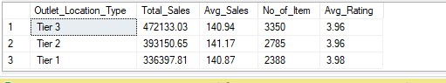

SELECT Outlet_Type,

CAST(SUM(Sales) AS DECIMAL(10,2)) AS Total_Sales,

CAST(AVG(Sales) AS DECIMAL(10,2)) AS Avg_Sales,

COUNT(*) AS No_of_Item,

CAST(AVG(Rating) AS DECIMAL(10,2)) AS Avg_Rating

FROM Blinkit_Data

GROUP BY Outlet_Type

ORDER BY Total_Sales DESC

